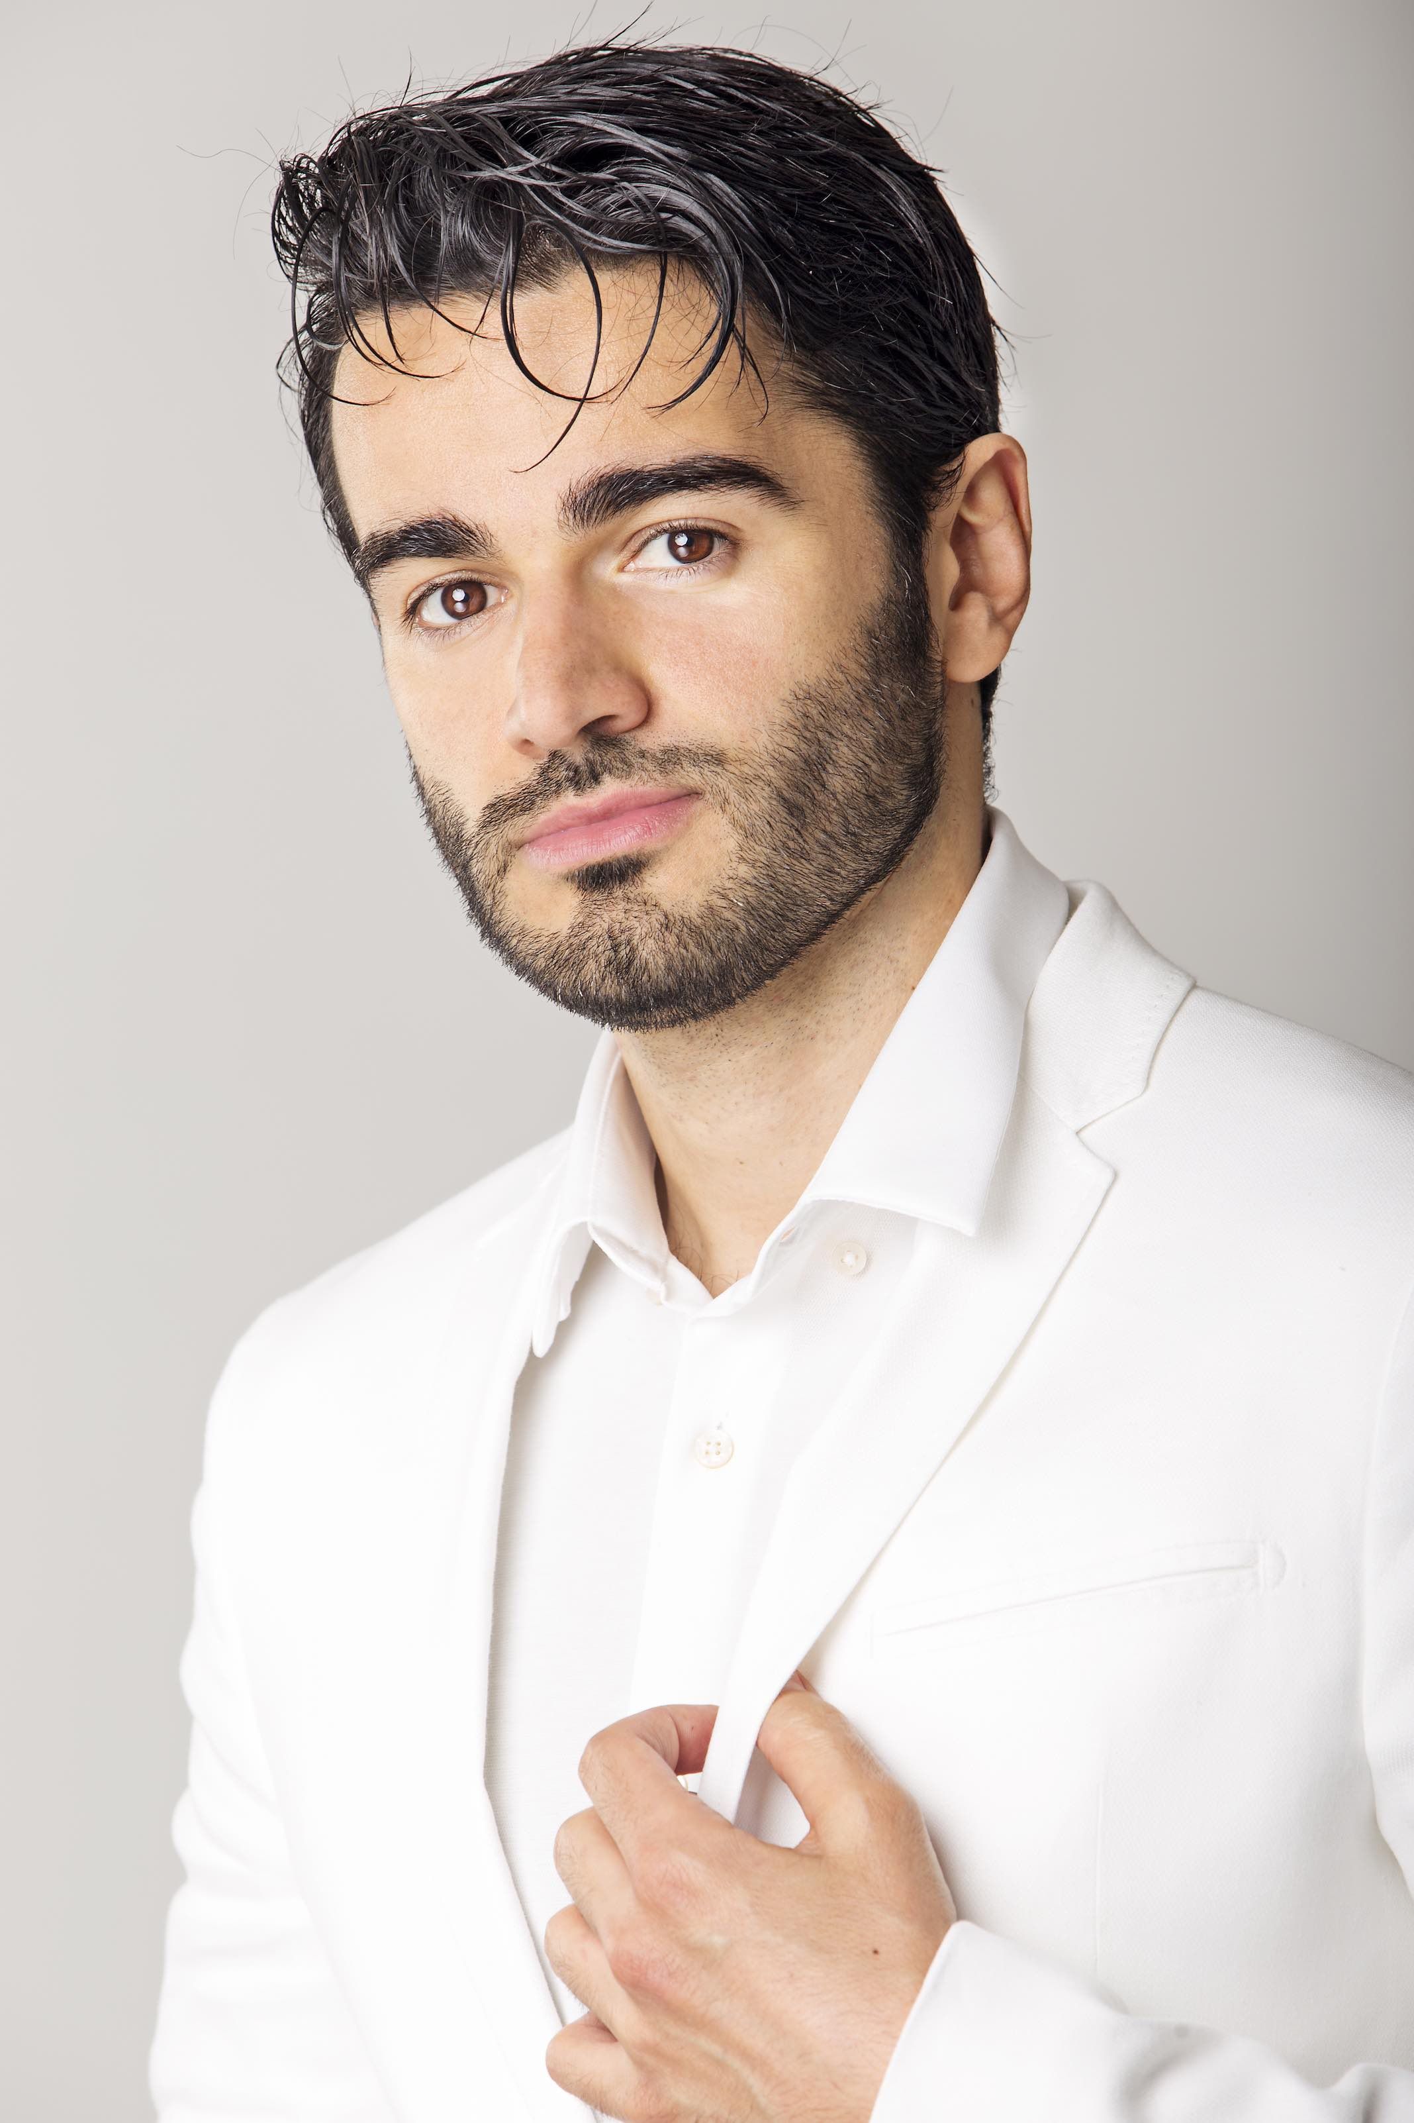  Anicio Zorzi Giustiniani  Tenor | Anicio Zorzi Giustiniani was born in Florence. A violinist for many years from a very young age, his focus shifted to singing shortly thereafter. His vocal studies began at Conservatorio Luigi Cherubini in Florence and after under the guidance of tenor Fernando Cordeiro Opa and of the soprano Silvia Bossa. His singing debuted occurred at Teatro della Pergola in Florence in 2001 as a soloist in Charpentier’s Te Deum. He has been recognized in numerous competitions, including the 6th Sacred Music International Competition in Rome and at the 39th International Singing Competition Toti Dal Monte in Treviso for the main male role in “La Vera Costanza” by Haydn. He subsequently debuted this opera in theaters of Madrid, Treviso, Reggio Emilia and Liège.  He has performed many lead roles throughout major international opera houses, including: Mozart’s Così fan tutte (Ferrando) and Don Giovanni (Don Ottavio) and Rossini’s Il Barbiere di Siviglia (Conte Almaviva) at Teatro La Fenice, Bellini’s I Capuleti e i Montecchi (Romeo - tenor version) at the Royal Opera House of Muscat, Mozart’s Betulia Liberata (Ozìa) under Riccardo Muti at the Salzburg Festival and the Ravenna Festival, Mercadante’s I Due Figaro (Il Conte Almaviva and Torribio) under Riccardo Muti at the Teatro Real de Madrid, the Salzburg Festival, the Ravenna Festival and the Teatro Colon in Buenos Aires, Lehar’s Die lustige Witwe (Camille de Rossillon) at the Teatro Filarmonico di Verona and at the Teatro Petruzzelli in Bari, Die Zauberflöte (Tamino) in the Opéra Royal de Wallonie in Liège and at Teatro La Fenice; Handel’s Giove in Argo, title role, at the Theater an der Wien in Vienna.  He worked with important conductors (such as Riccardo Muti, Michele Mariotti, Alessandro De Marchi, Paolo Arrivabeni, Pietro Rizzo, Hubert Soudant, Jeffrey Tate, Stefano Montanari, Ottavio Dantone, René Jacobs, Marc Minkowski, Emmanuelle Haim, Leonardo Garcia Alarcòn, Antonello Manacorda, Jesùs Lopez Cobos, Fabrizio Maria Carminati...) and stage directors (such as Robert Carsen, Damiano Michieletto, Emilio Sagi, Gabriele Lavia, Arnaud Bernard, Tobias Kratzer, David Bösch...).  Recently he has appeared in: Falstaff in Chicago with the Chicago Symphony Orchestra conducted by Riccardo Muti; Handel’s Alcina (Oronte) in Montecarlo, Toulouse, Versailles with Philippe Jaroussky and Ottavio Dantone; Lucrezia Borgia (Gennaro) in Sankt Gallen staged by Tobias Kratzer; Idomeneo (Arbace) in Venice; Hasse’s Artaserse, title-role, Festival della Valle d’Itria; L’Infedeltà delusa in Köln with Andreas Spering; Stravinsky’s Pulcinella in Florence with Antonello Manacorda; Il viaggio a Reims (Cavalier Belfiore) in Jesi; Gounod’s Romeo et Juliette (Thybalt) in Verona; Haydn’s La vera costanza (Il Conte Errico) in Liège; Petite Messe Solennelle in Florence.  Has has recorded for: Deutsche Grammophon (Haendel’s Ezio, conducted by Alan Curtis), Emi Virgin (Haendel’s Berenice, Giove in Argo and Ariodante, conducted by Alan Curtis), Glossa (Monteverdi’s Il ritorno di Ulisse in patria, title role, conducted by Claudio Cavina and Caldara’s Morte e sepoltura di Cristo conducted by Fabio Biondi), Bongiovanni (Moneta’s Il conte Policronio), Hyperion (Cesti’s Le disgrazie d’amore), Ducale music (Mercadante’s I due Figaro, conducted by Riccardo Muti), Naxos (Morlacchi’s Tebaldo e Isolina, conducted by Antonino Fogliani), Dynamic (Hasse’s Artaserse).  Recent and forthcoming engagements include: Handel’s Alcina (Oronte) in the Opéra des Nations in Geneva with Leonardo Alarcòn, Gluck’s Alceste (Evandro) for Ruhrtriennale with René Jacobs; Monteverdi’s Orfeo in Lausanne in a new production of Robert Carsen; Cimarosa’s Il Matrimonio segreto (Paolino) in Nancy, Opéra National Lorraine, Mozart’s Così fan Tutte (Ferrando) in Drottningholm, Versailles and Bucarest with Mark Minkowski and in Lille with Emmanuele Haim; Mozart’s Don Giovanni (Don Ottavio) at the Opéra de Lausanne at La Fenice in Venice and at the Opera in Rome; Gluck’s Le Cinesi (Silango) in Valencia with Fabio Biondi; Monteverdi’s Il ritorno di Ulisse in Patria (Telemaco and Giove) and Haydn’s Armida in a european tour with René Jacobs; Bach’s Matthew’s Passion (Evangelist) with Marc Minkowski in an European tour; Mozart’s Die Zauberflöte (Tamino) in Salerno and Idomeneo (Idamante) at the Teatro Real de Madrid; Handel’s Alcina (Oronte) in Glyndebourne; Donizetti’s Don Pasquale (Ernesto) in Bruxelles and Seville; Rameau’s Les Indes Galantes in Genève.  July 2019

